Student friendly

Co-op Academy Grange
The
Coop Academy is our Academy and we want it to be a safe place for every pupil. We will always do everything we can to make sure that every pupil within our Academy is safe both inside and outside of our Academy.

Keeping you safe is what matters most to all of the staff at Coop Academy

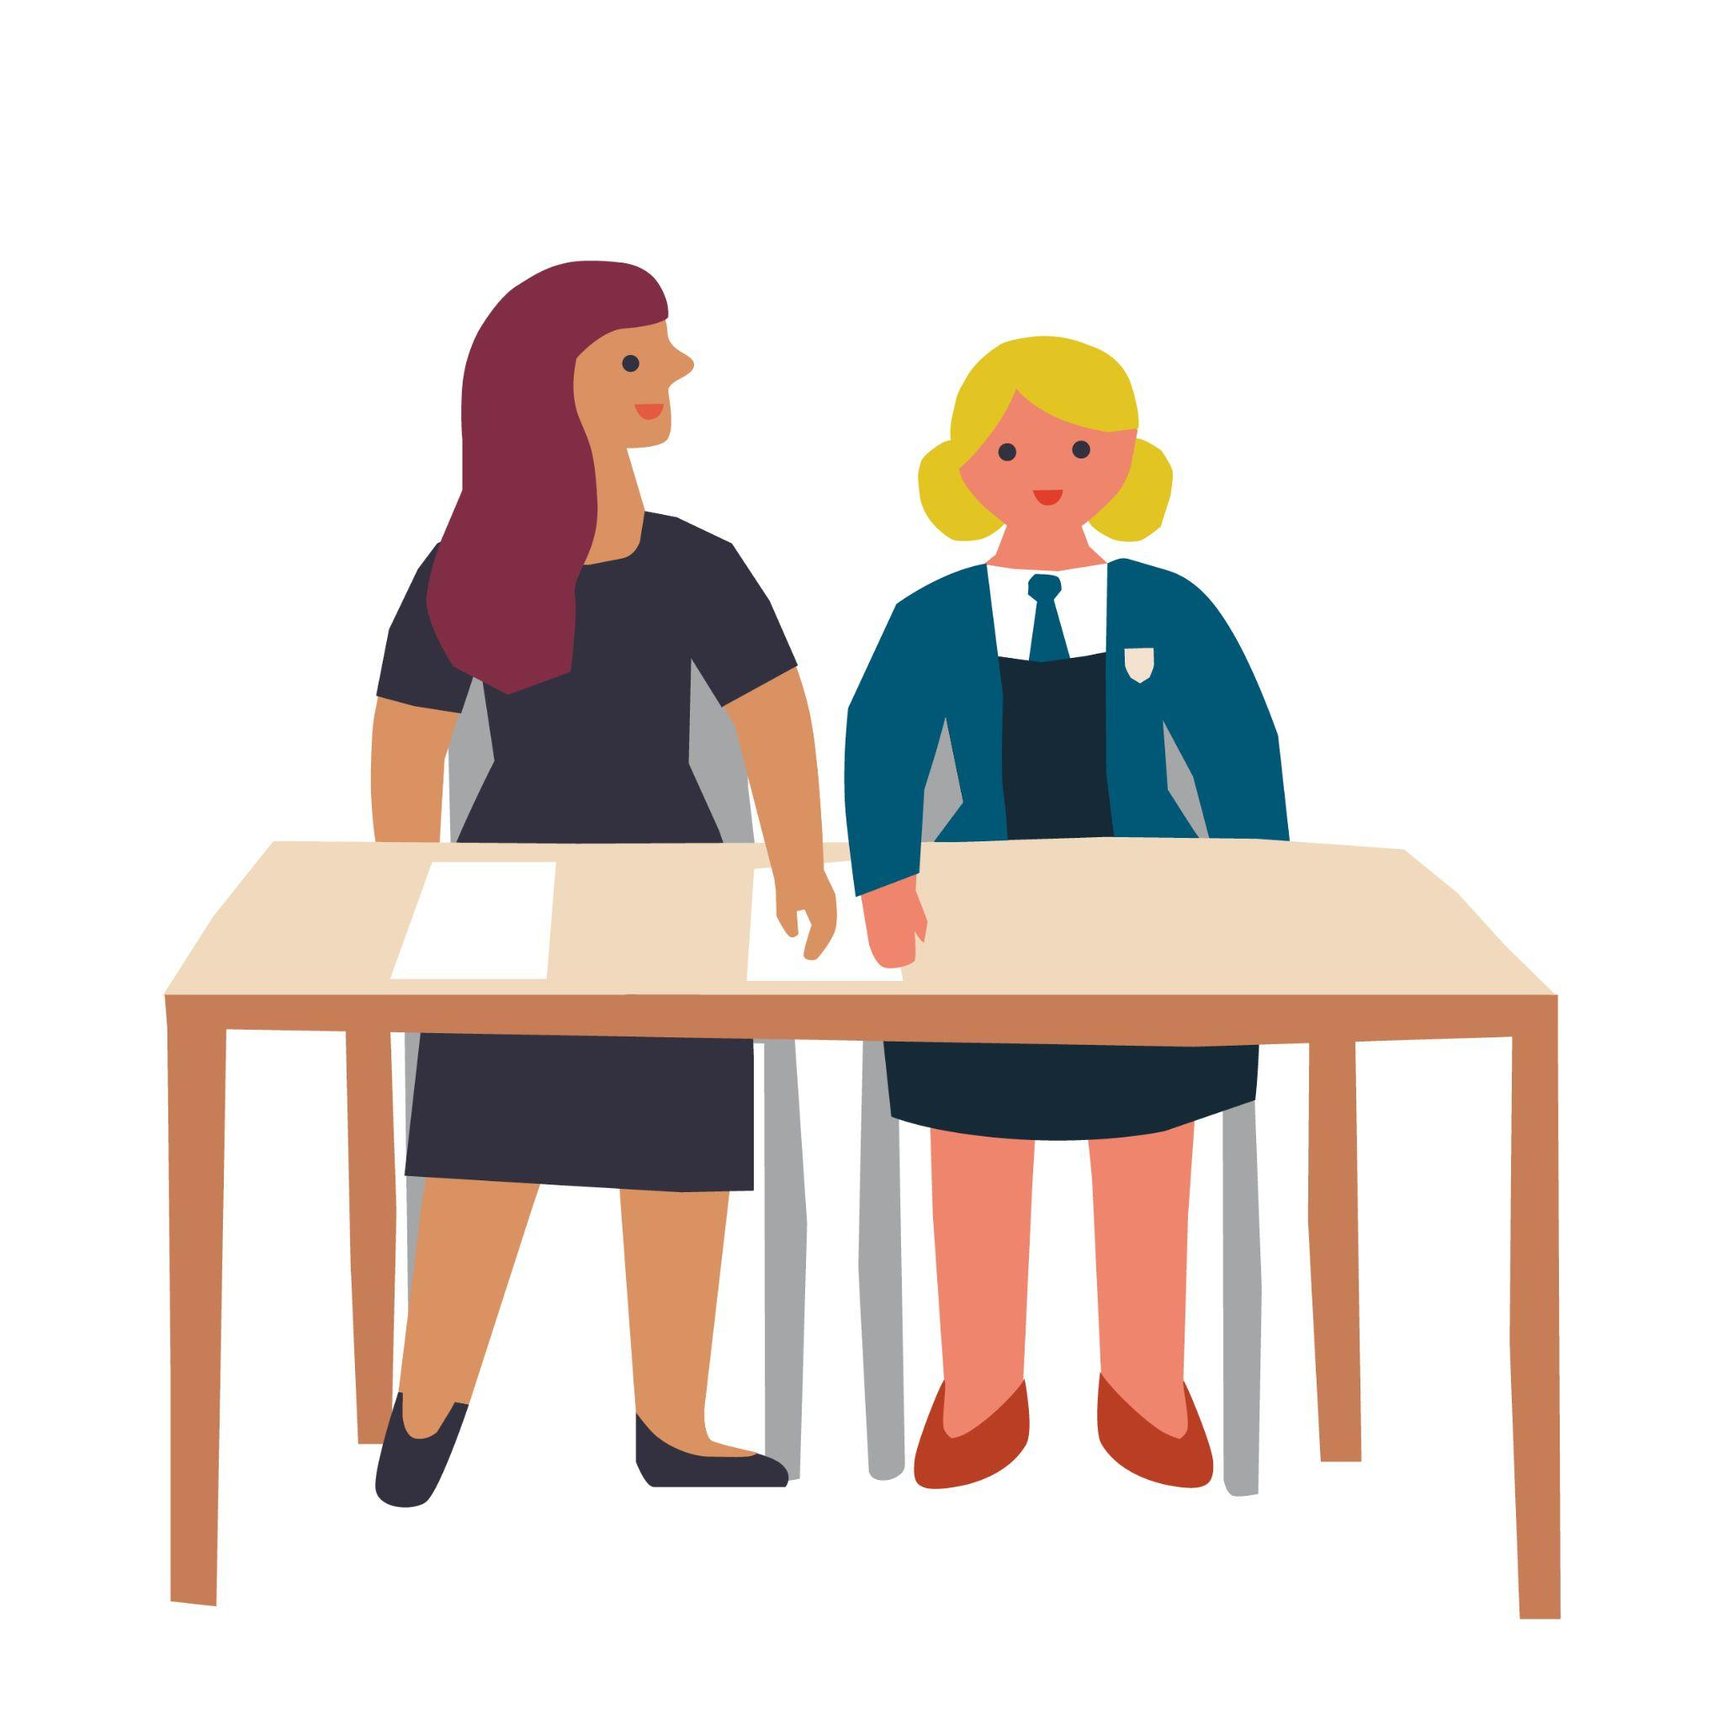
This policy is to help you understand what Safeguarding means to you and to help you decide what could be a “problem” and whom you should talk to.

What is safeguarding?

Staff in our Academy know that Safeguarding means that they should:

- Protect you from harm;
- Make sure nothing stops you being healthy or developing properly;
- Make sure you are safely looked after;
- Make sure you have the best life chances and can grow up happy and successful

All Staff in our Academy will make sure they look after you by:

- Making the Academy a safe friendly, welcoming and supportive place to spend time in – somewhere you want to be
- Be there for you to talk to if you need to and know who to ask for help
- Give you guidance in your lessons to help you learn how to look after yourself both online and in the real world
- Doing our best to spot if there is a problem. All of the staff in our academy have been taught how to do this.
- Have all the right rules and procedures in place to help look after you. They will follow these rules and procedures all of the time (these rules are sometimes called policies)
- Supporting and encouraging you, and listening to your wishes and views.

Abuse

When someone hurts, harms or takes advantage of you it can be called abuse. This is when someone does something to you that is harmful, unpleasant or painful like:

- If someone deliberately hits you, hurts you, injures you or humiliates you in different ways
- If someone says or does something that makes you feel bad about yourself or hurts your feelings which makes you feel scared, sad, upset or frightened
- If someone shouts, threatens, hits or hurts someone you love whilst you are around which makes you scared, unhappy or worried
- If someone doesn’t take proper care of you, you feel abandoned, lonely or neglected. You might not be able to eat or wash regularly, or you might not be able to come to school every day or on time.
- If someone touches you in a way that you don’t like, for example touching your private parts.
- If someone makes you look at things or do things which make you feel ashamed, embarrassed, uncomfortable or guilty. They may ask you to keep it a secret or give you presents.

Abuse is never ok and if you are being or have been abused you must remember – it is not your fault. You must always tell someone and they will help you by putting things or people in place to prevent it from happening again.

Who can I talk to if I have a problem?

You can talk to any member of staff in our academy if you have a problem. We will work together to help you. There are also other ways you can share your concerns with staff:

Report a concern button on the website - This option is available to you at any time day or night

What happens next?

The member of staff you have spoken to will make accurate and specific notes of discussions to make sure that all of your concerns are recorded. Safeguarding information about you will be stored on our electronic recording system, CPOMS.

The member of staff can not promise to keep secrets. They will explain that they have a
responsibility to report what has been said to someone else if they are worried
about your safety.

Sometimes to make sure you get the best support, a member of staff will need to talk to one of the designated safeguarding leads (DSL’s). Our DSL’s are specially trained members of staff who have lots of experience of supporting children and families.

The staff in school will work with you, and sometimes your family to make sure you are safe.

Sometimes the DSL’s may need to contact other agencies who help to safeguard children. This might include children’s social care (Social Workers) or the police.

We know that sharing your problems can feel scary. Anything that we do will always be done with your safety as our main priority and following our academy rules.
The staff in our academy that are helping you will explain this to you and you can ask them any questions you need to.
We will always do our best to keep you informed of what is happening and what will happen next. Where we are not able to do this we will explain why.

Criminal Exploitation

Criminal Exploitation is when individuals or gangs target young people and force
them to carry out criminal activity. The individuals or Gangs (Exploiters) may force young people to dealdrugs, steal, commit violent or sexual acts and traffic them to other towns or cities. Children who are being criminally exploited are usually threatened and/or beaten by the people exploiting them – but exploitersare smart: they’ll spend months or years grooming their victims, and sometimes the young person may not even know it is happening to them.

Child Sexual Exploitation

CSE stands for Child Sexual Exploitation and is a form of sexual, emotional and physical abuse. It often the young person being given food, accommodation, drugs, affection, presents/gifts and money in return forperforming sexual acts. It usually involves the young person being beaten or threatened and intimidated if
they don’t do what they are asked to do by the person who is exploiting them.
Criminal Exploitation and Sexual Exploitation are never ok and if you are being or have been exploited you must remember – it is not your fault. You must always tell someone and they will help you by putting things or people in place to prevent it from happening again.

Sexual Violence and Sexual Harassment between children
Sexual Violence and Sexual Harassment between children is unwanted sexual behaviour that occurs between two children (or more) of any age or sex. This behaviour can be online or in person and can be either physical, verbal or both. Examples of sexual violence and sexual harassment could be sexualised comments or sexually touching another person in a way that makes them feel, embarrassed, intimidated or degraded. The term up-skirting refers to somebody taking a picture under someone else’s clothing without that person knowing and is a crime and we will not tolerate this behaviour in our Academy.

Agencies that support young people in our academy

Barnardos
Step 2
Emerge
CAMHS (Child and Adolescent Mental Health Service)
Educational Psychologists
School Nursing Team
Bradford Stronger families
Youth Justice team
Breaking the Cycle
Bradford Children’s and Families Trust
Early Help
West Yorkshire Police

Safeguarding System

This flowchart shows how the safeguarding system at Coop Academy Grange works. At every stage the adults will listen to your voice and make a record of any action they take. The safeguarding team has access to these records. This helps us to keep you safe.



