Parent friendly

Co-op Academy Grange
The
Coop Academy is our Academy and we want it to be a safe place for every pupil. We will always do everything we can to make sure that every pupil within our Academy is safe both inside and outside of our Academy.

Keeping your child/ren safe is what matters most to all of the staff at Coop Academy

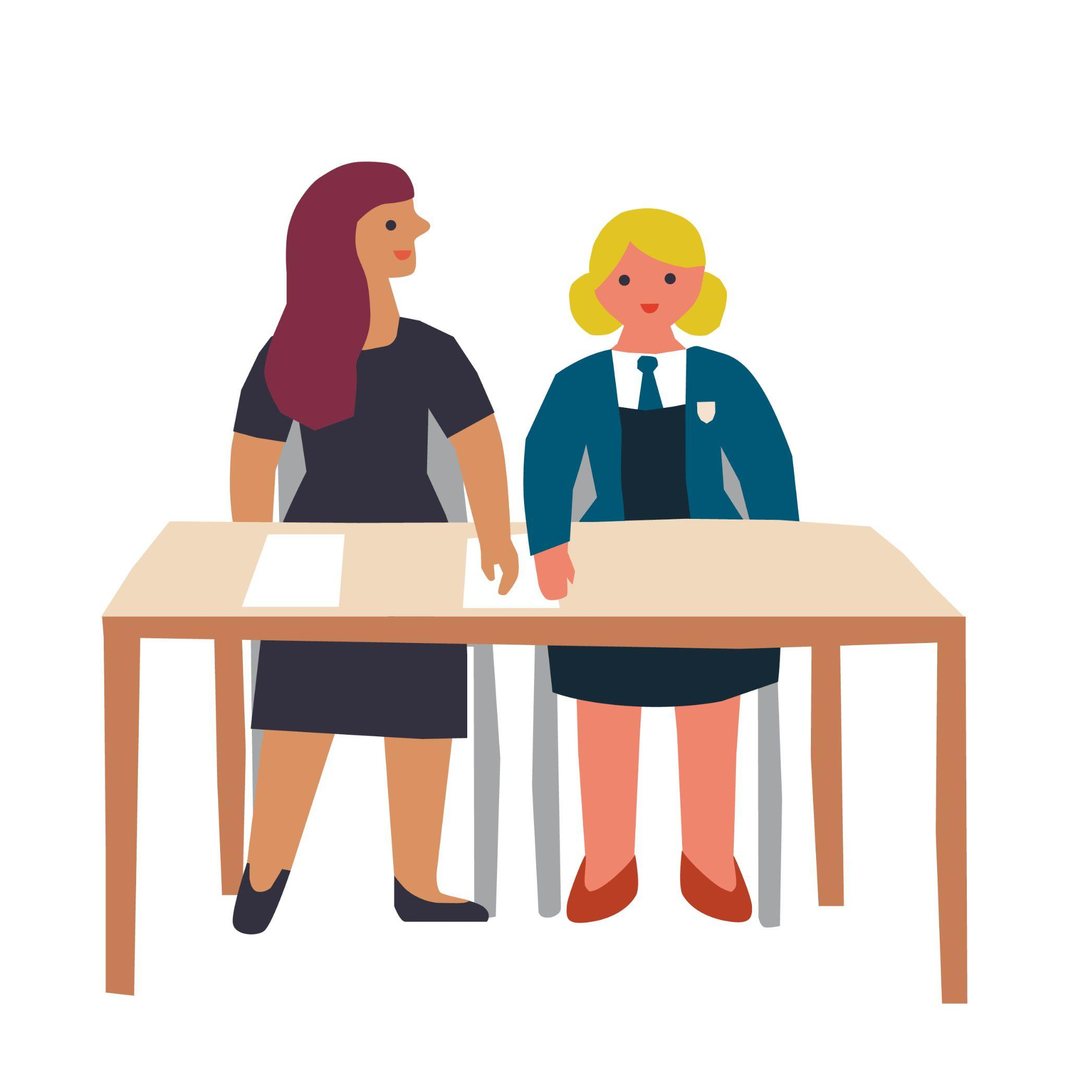
This policy is to help you and your child/ren understand what Safeguarding means to your child/ren and to help your child/ren decide what could be a “problem” and whom your child/ren should talk to.

What is safeguarding?

Staff in our Academy know that Safeguarding means that they should:

- Protect your child/ren from harm;
- Make sure nothing stops your child/ren being healthy or developing properly;
- Make sure your child/ren are safely looked after;
- Make sure your child/ren have the best life chances and can grow up happy and successful

All Staff in our Academy will make sure they look after your child/ren by:

- Making the Academy a safe friendly, welcoming and supportive place to spend time in – somewhere your child/ren want to be
- Be there for your child/ren to talk to if you need to and know who to ask for help
- Give your child/ren guidance in your lessons to help your child/ren learn how to look after yourself both online and in the real world
- Doing our best to spot if there is a problem. All of the staff in our academy have been taught how to do this.
- Have all the right rules and procedures in place to help look after your child/ren. They will follow these rules and procedures all of the time (these rules are sometimes called policies)
- Support and encourage your child/ren, and listen to your child/ren's wishes and views.

Abuse

If someone hurts, harms or takes advantage of your child/ren it can be called abuse. This is when someone does something to your child/ren that is harmful, unpleasant or painful like:

- If someone deliberately hits your child/ren, hurts your child/ren, injures your child/ren or humiliates your child/ren in different ways
- If someone says or does something that makes your child/ren feel bad about themselves or hurts your child/rens feelings which makes them feel scared, sad, upset or frightened
- If someone shouts, threatens, hits or hurts someone your child/ren love whilst your child/ren are around which makes them scared, unhappy or worried
- If someone doesn’t take proper care of your child/ren, your child/ren feel abandoned, lonely or neglected. Your child/ren might not be able to eat or wash regularly, or your child/ren might not be able to come to school every day or on time.
- If someone touches your child/ren in a way that your child/ren don’t like, for example touching your child/ren’s private parts.
- If someone makes your child/ren look at things or do things which make your child/ren feel ashamed, embarrassed, uncomfortable or guilty. They may ask your child/ren to keep it a secret or give your child/ren presents.

Abuse is never ok and if your child/ren are being or have been abused your child/ren must remember – it is not your child/ren’s fault. Your child/ren must always tell someone and they will help your child/ren by putting things or people in place to prevent it from happening again.

Who can your child/ren talk to if they have a problem?

Your child/ren can talk to any member of staff in our academy if your child/ren have a problem. We will work together to help your child/ren. There are also other ways your child/ren can share your child/ren’s concerns with staff:

Report a concern button on the website - This option is available to your child/ren at any time day or night

What happens next?

The member of staff your child/ren have spoken to will make accurate and specific notes of discussions to make sure that all of your child/ren’s concerns are recorded. Safeguarding information about your child/ren will be stored on our electronic recording system, CPOMS.

The member of staff can not promise to keep secrets. They will explain that they have a
responsibility to report what has been said to someone else if they are worried
about your child/rens safety.

Sometimes to make sure your child/ren get the best support, a member of staff will need to talk to one of the designated safeguarding leads (DSL’s). Our DSL’s are specially trained members of staff who have lots of experience of supporting children and families.

The staff in school will work with your child/ren, and sometimes your child/ren’s family to make sure your child/ren are safe.

Sometimes the DSL’s may need to contact other agencies who help to safeguard children. This might include children’s social care (Social Workers) or the police.

We know that sharing problems can feel scary for your child/ren. Anything that we do will always be done with your child/rens safety as our main priority and following our academy rules.
The staff in our academy that are helping your child/ren will explain this to your child/ren and your child/ren can ask them any questions your child/ren need to.
We will always do our best to keep your child/ren informed of what is happening and what will happen next. Where we are not able to do this we will explain why.

Criminal Exploitation

Criminal Exploitation is when individuals or gangs target young people and force
them to carry out criminal activity. The individuals or Gangs (Exploiters) may force young people to dealdrugs, steal, commit violent or sexual acts and traffic them to other towns or cities. Children who are being criminally exploited are usually threatened and/or beaten by the people exploiting them – but exploitersare smart: they’ll spend months or years grooming their victims, and sometimes the young person may not even know it is happening to them.

Child Sexual Exploitation

CSE stands for Child Sexual Exploitation and is a form of sexual, emotional and physical abuse. It often the young person being given food, accommodation, drugs, affection, presents/gifts and money in return forperforming sexual acts. It usually involves the young person being beaten or threatened and intimidated if
they don’t do what they are asked to do by the person who is exploiting them.
Criminal Exploitation and Sexual Exploitation are never ok and if you are being or have been exploited you must remember – it is not your fault. You must always tell someone and they will help you by putting things or people in place to prevent it from happening again.

Sexual Violence and Sexual Harassment between children
Sexual Violence and Sexual Harassment between children is unwanted sexual behaviour that occurs between two children (or more) of any age or sex. This behaviour can be online or in person and can be either physical, verbal or both. Examples of sexual violence and sexual harassment could be sexualised comments or sexually touching another person in a way that makes them feel, embarrassed, intimidated or degraded. The term up-skirting refers to somebody taking a picture under someone else’s clothing without that person knowing and is a crime and we will not tolerate this behaviour in our Academy.

Agencies that support young people in our academy

Barnardos
Step 2
Emerge
CAMHS (Child and Adolescent Mental Health Service)
Educational Psychologists
School Nursing Team
Bradford Stronger families
Youth Justice team
Breaking the Cycle
Bradford Children’s and Families Trust
Early Help
West Yorkshire Police

Safeguarding System

This flowchart shows how the safeguarding system at Coop Academy Grange works. At every stage the adults will listen to your child/rens voice and make a record of any action they take. The safeguarding team has access to these records. This helps us to keep your child/ren safe.

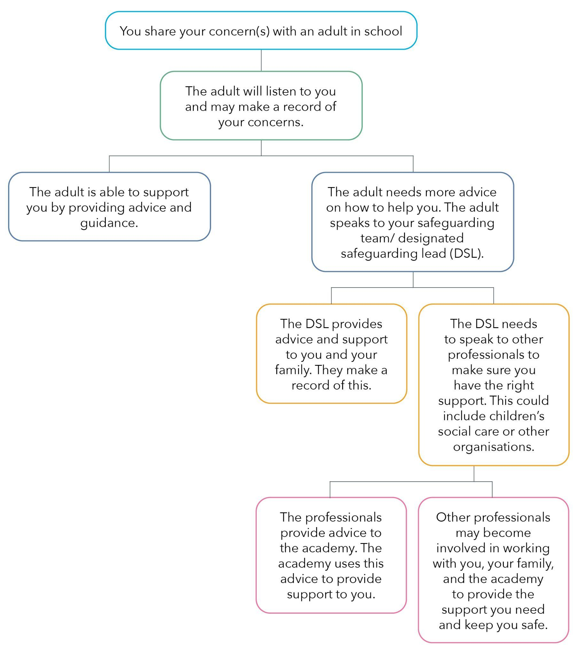

If you would like to read the full Safeguarding Policy this can be found on the Academy website or please follow the link here

